**ASSIGNMENT NO-13**

* **Problem Statement:-** Create a workmail for your organization.
* **Steps:-**

# Organisation Creation

1. In the search tab, type amazon workmail. In amazon workmail, click

# “Create Organisation”.

1. 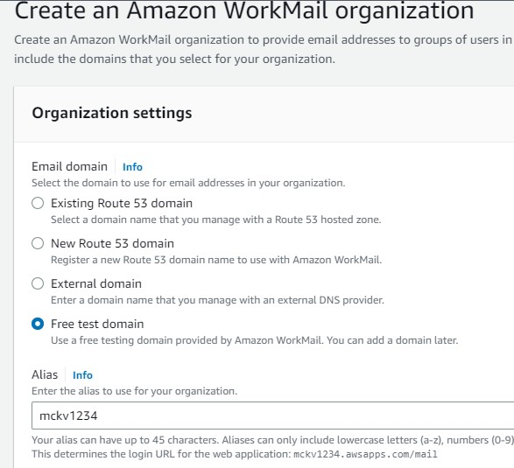In organization settings, click “**Free test domain”**. In Alias type name of your organisation(ex-mckv1234).
2. In organization, click **Users** in the left side window. In Users, click

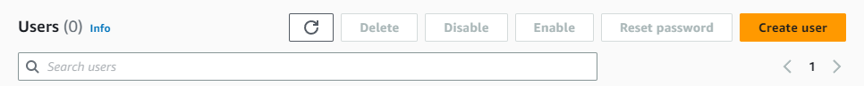 “**create user**”.

1. Type user name,first name,last name and give password and click create user.

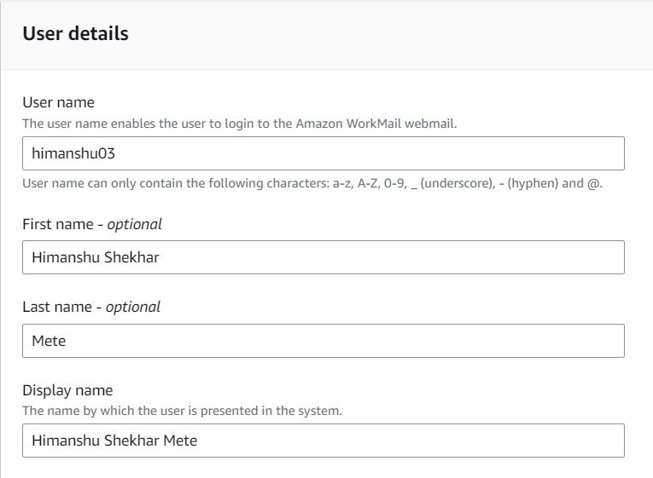

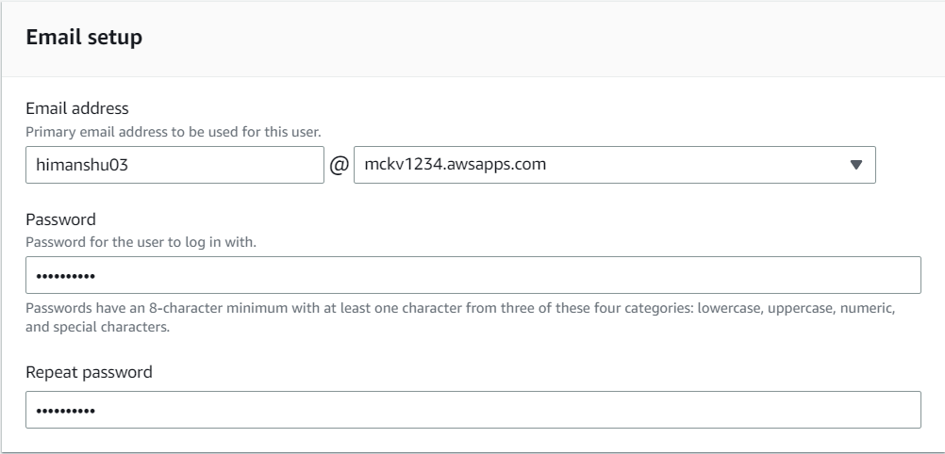

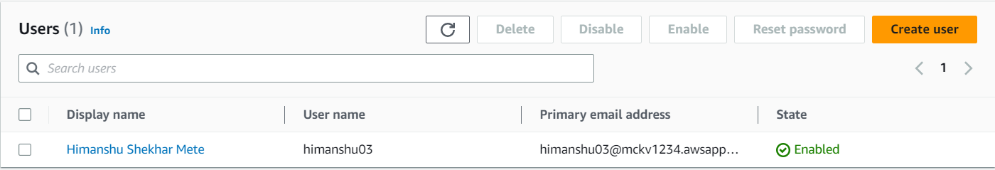

1. 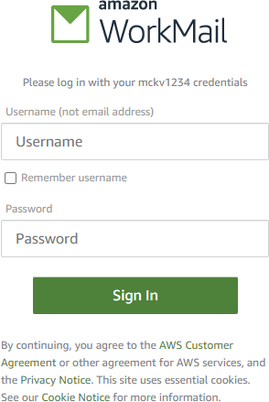Now, go to organization and click **Amazon workmail web Application.**
2. 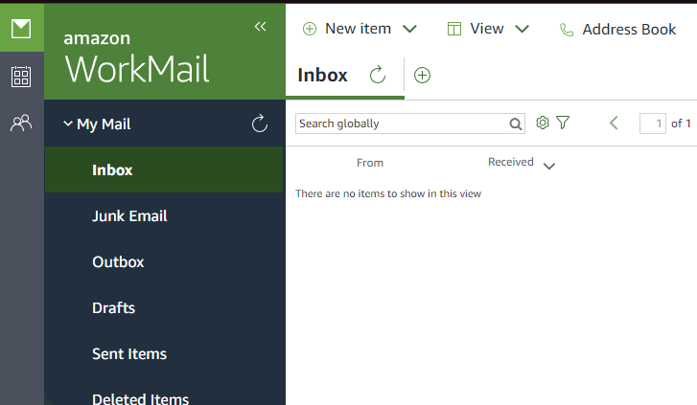Give username and password and it will open.

